**Static Design Task**

1. Layered Architecture:

|  |  |
| --- | --- |
| **APP** | Application |
| **ECUAL** | Motor  Button |
| **MCAL** | PWM  Timer  DIO |
| **Micro Controller** | |

1. Defining APIs:
2. GLOBAL Enum:

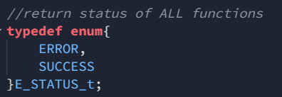

1. MCAL LAYER:
2. DIO APIs:

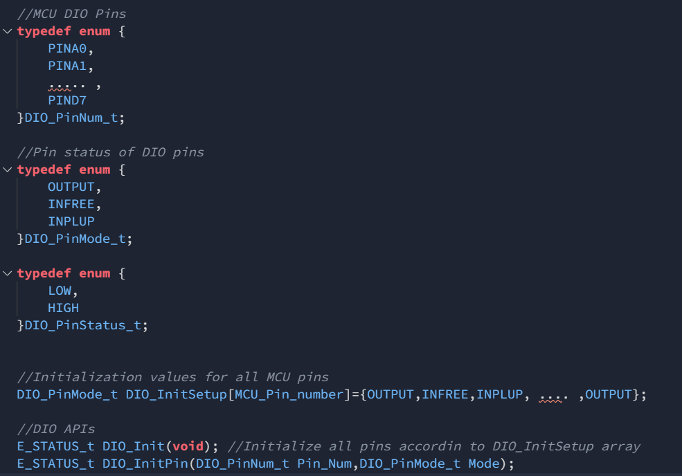

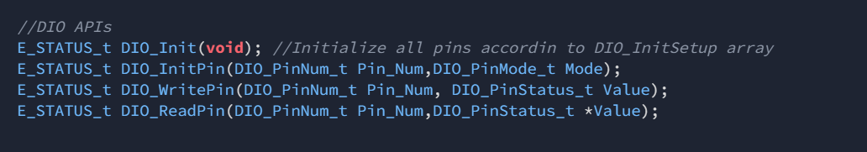

1. 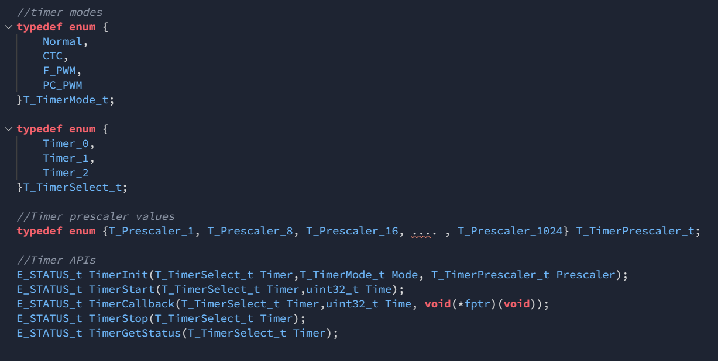Timer APIs:
2. PWM APIs:

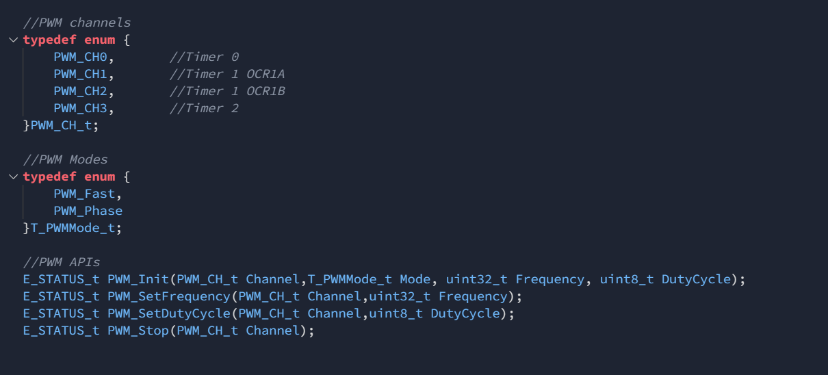

1. ECUAL APIs:
2. Button APIs:

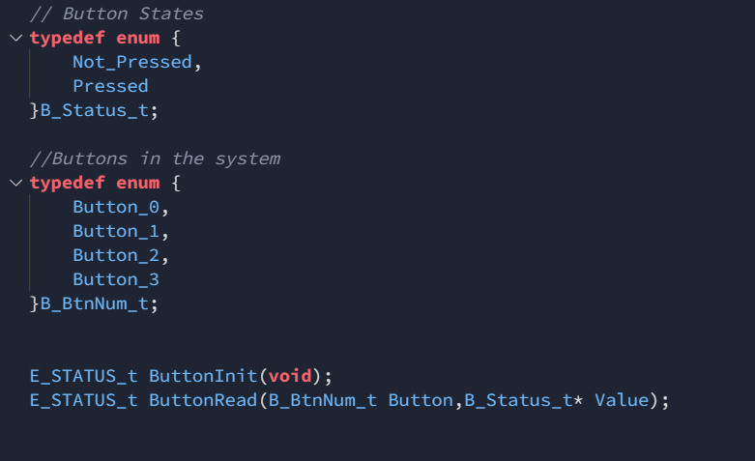

1. Motor APIs:

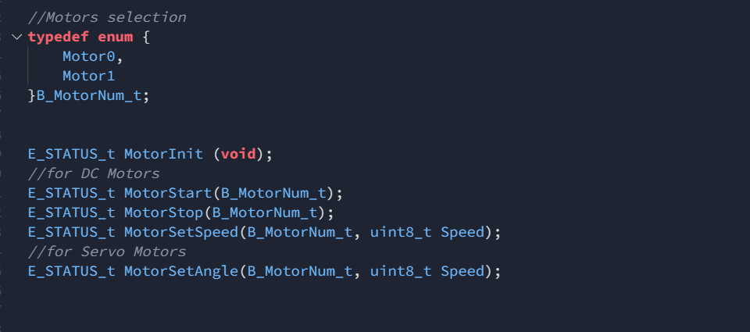

1. Application APIs:

